SE-1001

# Programming Fundamentals Lab

**Bank Management System**

Project Report By

**Ali Sarwar**

**Group Members:**

Ali SarwarSE 201039

Muhammad Hamza KhalidSE 201028

**Table of Contents**

1. Introduction 3

2. Scope 4

3. Module Description 4

4. Hardware : 4

5. Screen Shots 5

6. Flow Chart 5

# Introduction

Online banking (Internet banking or E-banking) allows customers to conduct online transactions on a secured system .Our project based on Mini Bank Management system in c. This project is based on customer account services in bank. This system allows user to signup account and other some activities like real bank.

# Scope

# The purpose of this project is in partial fulfilment of the requirements of customer using the online banking for payment. The Design and development of this Mini Bank Management system provides a more secured approach in managing bank customer’s information which strengthens the relationships between banks and their customers by providing the right solutions that uses a multi-level security to improve customer satisfaction.

# Module Description

* The whole process of banking is showed in the code like creating new account, displaying details, deposits, withdraw. This project is based on customer account services in bank.
* This system allows user to signup account.
* The user can enter account details to perform transactions.
* Check the details of an current account ,bank balance & credit card .
* Admin has the access of all the accounts (as a owner).
* This system allows deposit less than or equal to Rs 100000.

# Hardware :

* i3 2.2 GHZ processor or equivalent
* 2 gb ram
* 25 mb disk space
* Windows xp,7,8 & 10

**5.Software Requirements:**

* Codeblocks
* Sublime text code 3
* Notepad++/notepad

# Screen Shots

* 1. 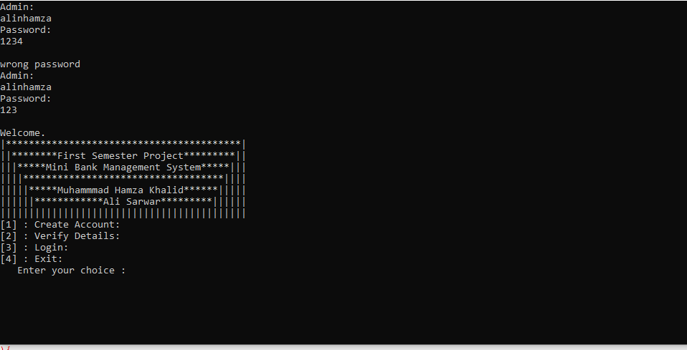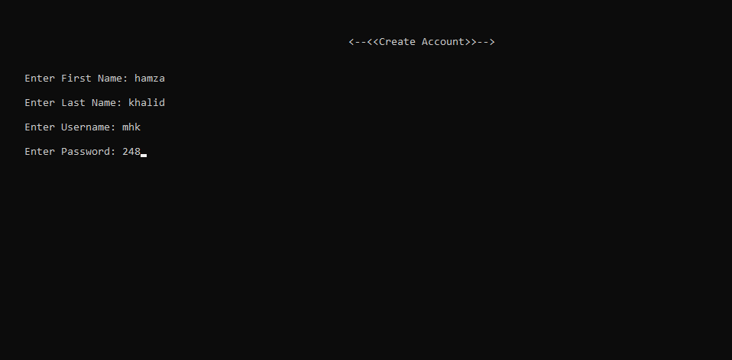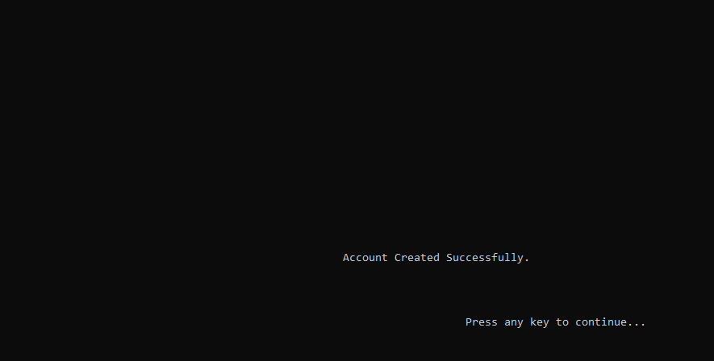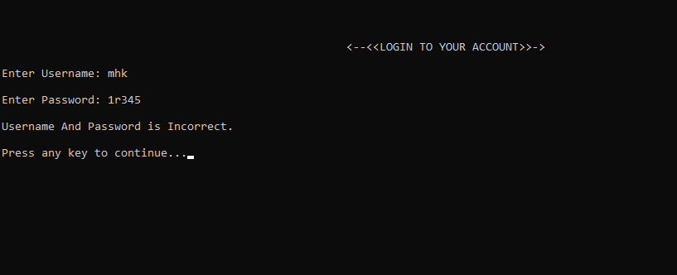

1. 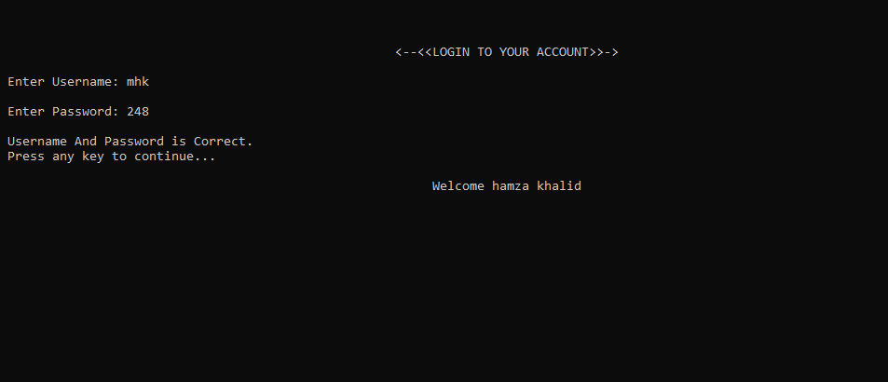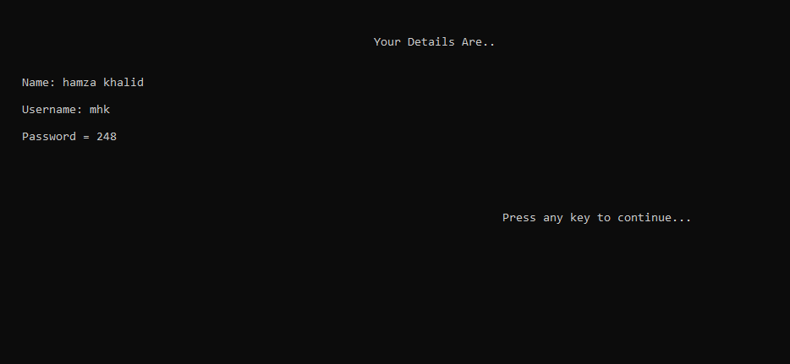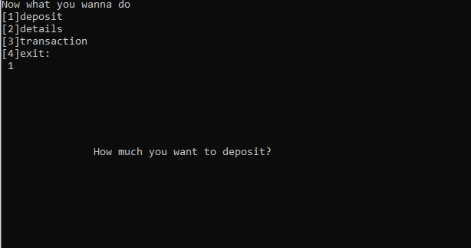
2. 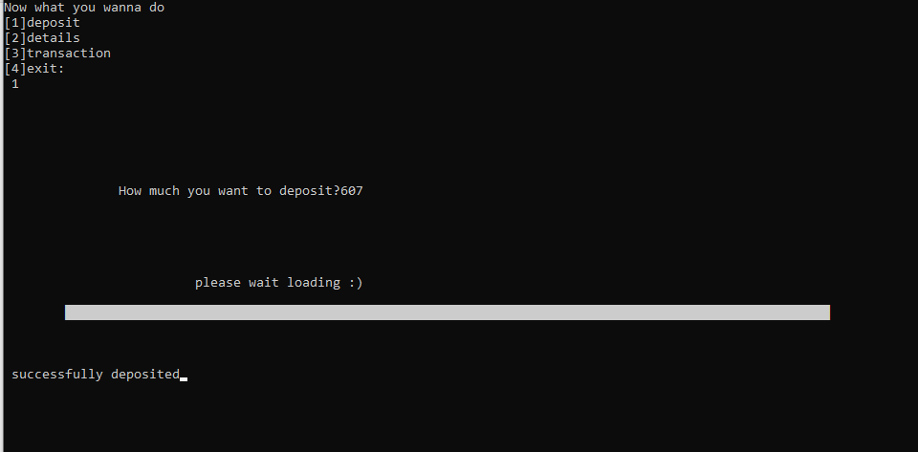
3. 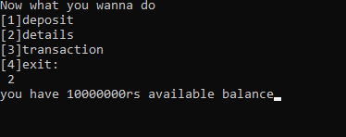
4. 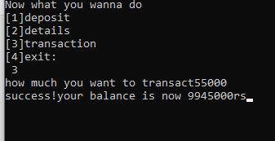
5. 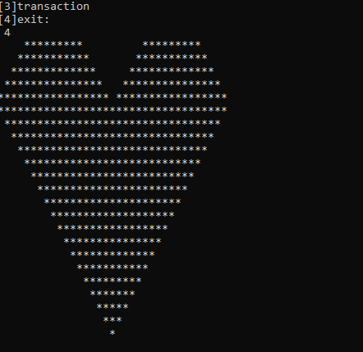

# 6. Flow Chart

